# **MODULE 1**

**What is Servicenow?**

Servicenow, founded by Fred Luddy in 2003 is a software company to solve problems faced by large enterprises with conventional IT delivery methods. The platform offers a powerful, user-friendly, cloud-based environment to empower business people to independently tackle and resolve their own business problems.  
  
**History of ServiceNow**

In 2003, Fred Luddy founded the company as GlideSoft.  
In 2006, the company was renamed as Servicenow.

In 2012, Servicenow becomes a publicly traded company.

In 2018, Servicenow becomes #1 on most innovative companies.  
In 2019, Bill McDermott became the CEO of Servicenow.

**Servicenow Platform**

* The Now Platform is an Application Platform as a Service(APaaS).
* It is cloud based
* It supports and provides Infrastructure computer resources.
* It provides a platform where you can develop your own custom solutions.
* It provides a robust set of applications and workflows to support most common business processes.
* All applications(OOB and custom) for the entire enterprise are supported by a single, common, data model and database.

**Applications and Workflows**

There are 4 primary workflows:

1. IT Workflows
2. Employee Workflows
3. Customer Workflows
4. Creator Workflows

**Now Platform Architecture**

* Enterprise Cloud

Most cloud services support multi tenant architecture in which your platform and data are co-mingled with other companies. Servicenow supports multi-instance architecture where you have your own instance of the platform and database.

* Availability and Redundancy

All datacenters are paired with another datacenter to provide redundancy and failover. Redundancy is built into every layer including devices, power, network resources.

* Backups and Security

4 full backups per week and 6 days of daily differential backups are supported. The platform is secured via multiple technologies which have been certified by various third-party security organizations.

* Domain Separation

Servicenow platform provides the ability to separate data, processes and administrative tasks on an instance into logical groupings called domains.

**User Interfaces**

Servicenow provides 3 user interfaces for interacting with the Now Platform:

The Now Platform is the primary UI. It is best suited for desktop and laptops. It can be accessed via a web browser and the instance URL.

The Servicenow Mobile Apps are best suited for mobile devices and can be installed from the app strore.

* The Servicenow Agent app targets fulfilling requests.
* The NowMobile app is built for the needs of the employees.
* The Onboarding app is built for the needs of new-hire employees.

The Service Portal is a user- friendly, self service, widget based portal accessed via a web browser and special URL.

**Role Based Access**

Not all members of an organization need to have access to all the information all the time. Servicenow ensures that the user gets access to the information they need and not more than that.  
The primary components include:

A User is an individual who can be assigned to one or more groups and can be granted multiple roles. A user with no roles is called a self service user. They can login and perform actions like viewing the homepage, Service catalog, articles and surveys.

A Group is a set of users who share a common purpose and access to similar information. A group can be assigned one or more roles.

A Role is a collection of permissions. A role can be assigned to an individual user, a group or a another role. Its best to assign roles to a group rather than a user.

**User Authentication**

When a user logins to an instance, Servicenow validates their identity and gives access to functions and information according to the user’s assigned roles and groups.

The platform can support several methods of user authentication:

* OAuth 2.0
* Single Sign-On(SSO)
* Multi-factor authentication
* Digest Token
* LDAP
* Local database authentication

**Servicenow Platform UI**

Three primary elements that make up the Servicenow platform UI:

* Banner Frame

Logo, User Menu, Tools, System settings

* Application Navigator

Navigation Filter, All applications, Favorites, History

* Content Frame

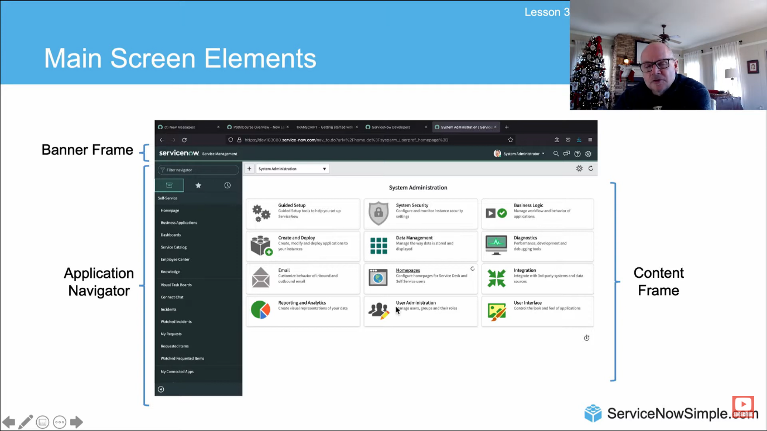

**Servicenow Branding**

Applying your distinct corporate identity across the Now Platform UI to create a shared identity, build trust and speed adoption.

Guided Setup:  
It provides the system admin step-by-step instructions to configure applications and modules within your instance.

To access guided setup, locate the guided setup application in the application navigator and select the ITSM guided setup or ITOM guided setup module.

Service Portal and UI Builder:

Service Portal and UI Builder are two additional tools to brand the interface.

Service Portal is a widget based tool that allows creation of intuitive, user-friendly interfaces to the Now platform.

UI Builder allows you to build out a functional page by clicking from a library of components(data and visualizations) and layouts.

**Forms**

A form in Servicnow is a common set of tools and user-interface elements used to view and update a single record from the database.

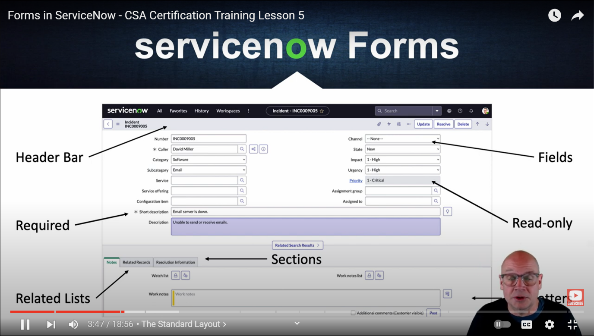

Form field types:

* String field
* Boolean(true/false) field
* List field
* Choice field
* Reference field
* Journal field

Form Related Lists

A related list is a special form element that displays a list of other records from another table related to the current record. (one to many relationship)

Form Formatters

A formatter is a special form element that displays information that is not a field in the record.

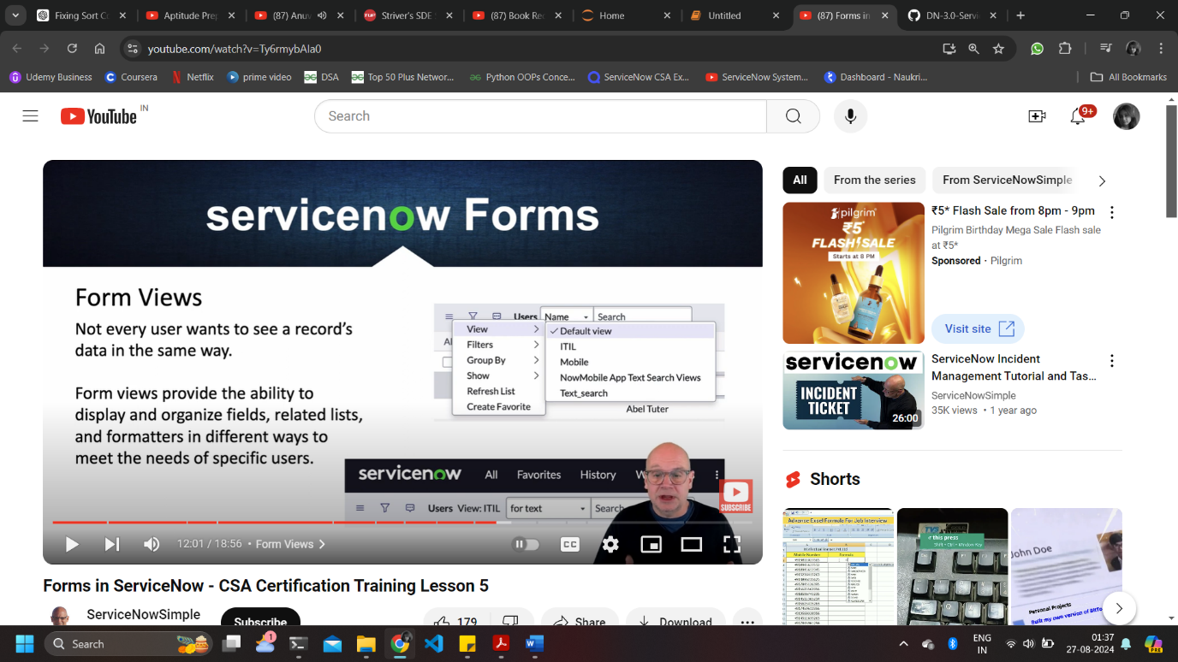Form Views

Not every user wants to see record data in the same way. Form view provide the ability to display and organize fields, related lists and formatters in different ways to meet the needs of specific users.

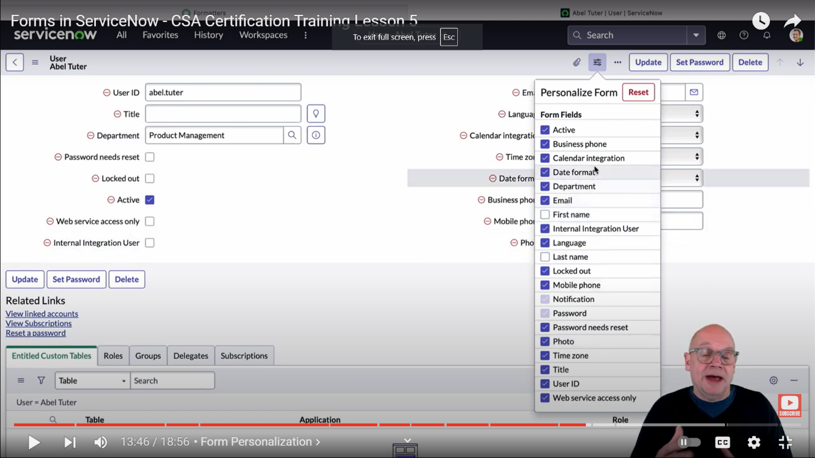Form Personalization

Form personalization allows users to select which fields are displayed on a particular form view. These changes don’t impact the form view of other users.